Structure-based Computational Prediction of Novel DYRK1A Inhibitors in Down Syndrome Associated Cognitive Impairment
ABSTRACT
Down syndrome (DS) is a genetic disorder affecting approximately 1 in 500 live births worldwide, characterized by cognitive impairments linked to overexpression of the DYRK1A gene on chromosome 21, a key kinase involved in neurodevelopment and synaptic function. Existing DYRK1A inhibitors exhibit limited selectivity and suboptimal pharmacokinetic properties, supporting the need for improved therapeutic small molecules. In this study, a library of 5,089 natural products obtained from Lotus Database was screened for potential DYRK1A inhibition. Of these, 2,665 compounds met Lipinski’s rule-of-five and were evaluated using a pharmacophore model to identify structural features critical for binding. The top 20 compounds were selected from the molecular docking-funnel, and further assessed for ADMET properties. Ten compounds demonstrated favorable pharmacokinetic profiles, and two were selected for lead optimization and density functional theory (DFT) analysis. Reference inhibitors included Epigallocatechin gallate (EGCG), Leucettine, and harmine. DFT analysis revealed that compound Molecule-358 exhibited the strongest DYRK1A inhibition, with optimal stability–reactivity balance indicated by a band gap of 4.64 eV, hardness of 2.32 eV, and low ionization energy of 4.95 eV. These findings suggest that Molecule-358 is a promising lead candidate for DYRK1A inhibition and warrants further in-vitro and in-vivo validation with molecule-63 also a close watch.
Keywords: Down’s syndrome, DYRK1A inhibitors, Cognitive impairment, CADD, Virtual Screening.

1. INTRODUCTION
Down syndrome (DS), the most common chromosomal aberration due to trisomy of the 21st chromosome with clinical features presenting as concomitant intellectual disability, congenital abnormalities, and progressive cognitive decline (Antonarakis et al., 2020). Individuals with DS commonly experience impairments in learning, memory, and executive function, which collectively manifest as Down Syndrome-Associated Cognitive Impairment (DSAC) (Godfrey & Lee, 2018). People with DS also exhibit a markedly increased predisposition to early-onset Alzheimer’s disease (AD), with neuropathological features developing decades earlier than in the general population (Godfrey & Lee, 2018, Lott & Head, 2019). Among the 21st chromosome genes, dual-specificity tyrosine phosphorylation-regulated kinase 1A (DYRK1A) has been a prime candidate in relating DS with a neuropathology via its overexpression causing neuronal malfunction and changing neurogenesis (Duchon & Herault, 2016, de Souza et al., 2023). The DYRK1A overactivity results in the hyper-phosphorylation of tau, the impairment of synaptic plasticity, and the activation of gliosis, which are the major factors responsible for DSAC and early-onset AD (Choudhury et al., 2025).
Hence, the DYRK1A kinase has been singled out as a possible target for the treatment of neurodegeneration due to DS (Deboever et al., 2022). The 3D structures of the enzyme showed certain active site residues that play a crucial role in the binding of ATP (PDB ID: 3ANR), which in turn enables the computer-aided design of specific inhibitors (Serrano-Candelas & Carpio, 2023). Structure-based drug development (SBDD) and molecular dynamics (MD) simulations have been key in the discovery of selective DYRK1A inhibitors that can penetrate the blood-brain barrier (BBB) and have minimized off-target kinase activity (Alam et al., 2025).
The most recent computational modeling and network pharmacology studies have pointed out a few new chemical structures with very strong DYRK1A inhibition and neuroprotective effects in preclinical models (Qiu et al., 2024). One of the compounds, Q17, for instance, showed a better cognitive outcome in the transgenic mouse models, which indicates the translational potential of structure-guided inhibitor discovery. Meanwhile, the combined structure-guided simulations and pharmacophore analyses are still deepening the understanding of ligand interactions with DYRK1A, which in turn, allows the development of the next generation of selective inhibitors (Scarano, 2025).
In this study, we employed comprehensive structure-based computational techniques such as molecular docking, pharmacophore modeling and absorption, distribution, metabolism, excretion and toxicity (ADMET) screening to unveil and investigate the new DYRK1A inhibitors which were directed at the active form depicted by PDB ID: 3ANR. The designed computational pipeline is expected to facilitate the development of promising lead compounds with the desired property of treating Down Syndrome-related cognitive deficit, and thus, to meet the clinical need for effective DYRK1A-based therapies.
In the course of the study, the results obtained at each stage of the workflow employed were benchmarked against the identified co-crystalized ligand (Harmine), Leucettine and Epigallocatechin gallate (EGCG) based on the progress in previous literature. These compounds share translational limitations in selectivity, unverified human safety and suboptimal ADME profile, including inadequate distribution across the BBB (Debdab et al., 2011; Stagni et al., 2017; Liu et al., 2022 ).

2. MATERIALS AND METHODS
To identify potential DYRK1A inhibitors, a systematic structure-based computational workflow was employed. The approach combined ligand and protein preparation, drug-likeness screening, pharmacophore modeling, molecular docking, binding energy estimation, which was done on Schrödinger Suites 2021-2 (Maestro 12.8) (Schrödinger, LLC, New York, NY) software, ADMET profiling and density functional theory (DFT) to evaluate the stability, reactivity, and interaction potential of candidate compounds. This pipeline allowed for the prioritization of the most promising molecules for lead optimization and potential therapeutic development.

2.1 Ligand and Protein Preparation
2.1.1 Ligand preparation
The natural chemical compounds libraries used for this computational screening was Lotus Database (Rutz et al., 2022) with about 276,518 natural products. 5,089 compounds were retrieved from Lotus database alongside their structure in SDF format and imported into Maestro. The compounds were prepared using the LigPrep module on Maestro (Wang et al., 2001). The compounds were then filtered based on compliance with Lipinski's rule (Lipinski et al., 2001), to determine if the compound will have good oral bioavailability. 2,665 compounds satisfied the Lipinski criteria.
Additionally, Harmine, the co-crystallized ligand, Leucettine and Epigallocatechin Gallate (EGCG) were identified and retrieved from PubChem, and prepared similarly to the other ligands and afterward utilized as a reference drug.

2.1.2 Protein Preparation
The protein 3ANR was obtained from RCSB PDB. The protein was prepared using Maestro Schrodinger Suite’s protein preparation wizard tool. Bond orders were assigned, hydrogens were added, zero-order metal bonds, disulfide bonds, water molecules were eliminated, and het states were generated using Epik at pH 7.0 ± 2.0 during the preprocessing of proteins. The H-bond assignment was optimized, and the protein was then reduced using the OPLS4 force field.

2.2 Pharmacophore Hypothesis
The co-crystallized ligand (Harmine) was analyzed to identify key structural features responsible for its interaction with DYRK1A. This evaluation revealed a three-point pharmacophore consisting of one hydrogen-bond acceptor (A1) and two aromatic ring features (R7 and R8). Using these elements, a pharmacophore hypothesis was generated and applied to the 2,665 compounds that satisfied Lipinski’s Rule of Five. Initial screening with a 2/3 feature-matching threshold yielded 1,071 compounds with fitness scores above 1.0 (1.007–2.826). Increasing the requirement to a full 3/3 match refined the set to 297 compounds, of which 281 also achieved fitness scores greater than 1.0 within the same range.

2.3 Grid Generation
The active site of 3ANR was characterized by determining its binding orientation and size using the receptor grid generation module on Schrödinger Maestro software (Omoboyowa et al., 2022). This grid was centered on the Harmine molecule, effectively creating a defined "search space" for the docking calculations. This step provides specific X, Y, and Z coordinates that pinpoint the center of the active site. The specific coordinates for the center of this grid were identified as X=6.99, Y=27.26, and Z=11.9.

2.4 Docking Study
In this study, all 281 filtered ligands were docked using the High-Throughput Virtual Screening (HTVS) docking protocol, and a docking score threshold of -5.0 kcal/mol was used. The top 20 compounds were subsequently then docked using the Standard Precision (SP) technique and were filtered again using a docking score threshold of -7.0 kcal/mol. The top 20 compounds from the HTVS screening were also docked using the Extra Precision (XP) model.

2.5 MM-GBSA
Molecular mechanics generalized born surface area (MM-GBSA) analysis was performed on the top 20 compounds from the HTVS, SP and XP docking funnel. The docking was carried out on the compounds that passed the pharmacophore hypothesis including the co-crystalized ligand and the two compounds utilized as standard comparison, Leucettine and EGCG. The analysis was simulated on the Schrödinger suites software to run the free binding energy calculations.
The MM-GBSA calculations were performed to refine binding affinity predictions from the XP docking. This evaluation estimates the binding free energy of the protein-ligand complex indicating the post-docking behavioral stability in the biological system, if fit (Osunnaya et al., 2025).
Using the formular (I), the MM-GBSA calculation approach employed to estimate the binding free energies utilized the OPLS3e force field, MM-GBSA continuum solvent and the VSGB 2.0 solvation model (Omer et al., 2022).
ΔGbind = ΔGcomplex - (ΔGligand + ΔGprotein) (I)
Where;
ΔGbind = the binding free enery
ΔGcomplex = Energy of the protein inhibitor
ΔGligand = Energy of ligand
ΔGprotein = Energy of protein

2.6 ADMET
The ADMET analysis was carried out on the top 10 screened out compounds from the docking and MM-GBSA score scrutiny, including the co-crystalized ligand and the two compounds utilized as standard comparison, Leucettine and EGCG. The ADMET properties were viewed and sorted on the Microsoft Excel software after predictions were carried out on ADMETlab 3.0 web server (https://admetlab3.scbdd.com) (Fu et al., 2024).
This computational prediction phase helped scrutinize the safety profiles of the top drug candidates with favorable pharmacokinetic and physicochemical properties (Omoboyowa et al., 2023). Some of the screened properties include the BBB permeability, topological polar surface area (TPSA), lipophilicity, hepatotoxicity, cytotoxicity, Cytochrome P450 enzyme inhibition, P-glycoprotein (p-gp) inhibition, intestinal and oral bioavailability and mutagenicity.

2.7 Lead Optimization
The top two (2) compounds were chosen for optimization after scrutinizing their ADMET profiles, docking and MM-GBSA scores. The ligand-protein interactions were carefully studied on the Maestro software and areas of suitable structural optimization were identified (Rowbottom et al., 2012). XP docking and MM-GBSA calculations were performed on the compounds to determine the best optimized compounds. The ADMET profile for the overall best analogs was estimated in order to evaluate and optimize poor profiles while maintaining an optimal docking score.

2.8 DFT
The DFT calculations were performed with B3LYP functional method and 6-31G* basis set on the Spartan ’10 1.1.0 software for the top three optimized analogs after obtaining the best conformation and the two leads. The DFT calculations were also carried out for the two compounds utilized as standard comparison, Leucettine and EGCG as well as the co-crystalized ligand. The calculations obtained parameters that indicated the stability, reactivity and thermodynamic nature.
Some of these parameters include the highest occupied molecular orbital energy (E_{HOMO}), lowest unoccupied molecular orbital energy (E_{LUMO}), energy band gaps (Eg), ionization energy (I), electron affinity (A), chemical hardness (η), chemical softness (δ), chemical potential (μ), electronegativity (χ). The values of these parameters were obtained using the following applicable formulas. I = - (E_{HOMO}) and A = - (E_{LUMO}). δ is the inverse of η (Bitew et al., 2021).
E.g. = E_{LUMO} - E_{HOMO} (II)
η = (I – A) (III)
2
χ = - μ = (I + A) (IV)
2

3. RESULTS AND DISCUSSION
3.1 Lipinski Screening and Pharmacophore Hypothesis
3.1.1 Lipinski Rule-of-Five Analysis
To evaluate the drug-likeness of the ligand dataset, Lipinski’s Rule-of-Five (RO5) was applied as an initial filtration criterion. RO5 provides essential guidelines predicting a compound’s likelihood of exhibiting acceptable oral bioavailability, based on constraints in molecular weight, lipophilicity, and hydrogen-bonding capacity (Lipinski, 2004). A total of 5,089 natural compounds were retrieved from the LOTUS data-base, 2,665 compounds met all four RO5 criteria without any violations. This represents a major refinement of the dataset, indicating that slightly more than half of the screened compounds possess physicochemical properties compatible with oral drug development. These RO5-compliant ligands were subsequently advanced to pharmacophore-based screening.

3.1.2 Pharmacophore hypothesis
Pharmacophore analysis was performed to identify key molecular features required for interaction with the DYRK1A active site. Evaluation of the co-crystallized ligand revealed a three-feature pharmacophore consisting of one hydrogen-bond acceptor and two aromatic ring systems, each contributing to the molecular interactions stabilizing ligand binding. These included one hydrogen-bond acceptor (A1) and two aromatic ring features (R7 and R8).
The hydrogen-bond acceptor feature (A1) had a tolerance of 2.00 Å and an associated interaction energy of –0.47 kcal/mol, indicating a moderate but essential role in anchoring the ligand through hydrogen bonding with active-site residues. The two aromatic ring features, R7 and R8, also displayed 2.00 Å tolerance values, with interaction energies of –1.33 kcal/mol and –1.35 kcal/mol, respectively.
Screening of the 2,665 ligands using this pharmacophore model was performed in two stages. Initial screening at a criterion of 2/3 match yielded 1,071 ligands. Increasing the stringency to a full 3/3 match resulted in 297 ligands, of which 281 maintained fitness scores >1.0. This demonstrates the capability of these compounds in engaging the key hydrogen-bond acceptor and dual aromatic interactions identified in the reference ligand.
Overall, the pharmacophore hypothesis served as a critical filtering step, reducing the ligand pool to a structurally relevant subset with high likelihood of productive interaction with DYRK1A. The alignment of these ligands with the essential A1, R7, and R8 features supports their potential suitability for subsequent docking and binding-affinity evaluation.

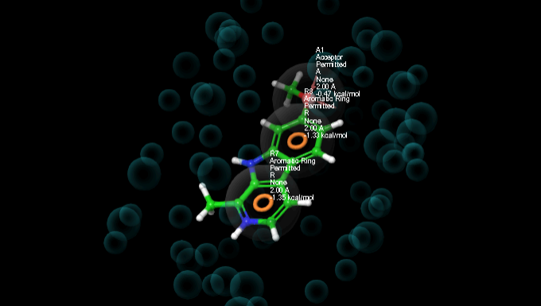
Figure 1. Pharmacophore hypothesis showing A1, R7 and R8 essential features.

3.2 Molecular Docking and MM-GBSA Analysis
The main goal of this research was to reveal new potential inhibitors of DYRK1A, a kinase responsible for Down Syndrome-related cognitive deficiency, via a computer-based approach that was based on the structure of the target protein PDB ID: 3ANR. The binding free energy calculations of MM-GBSA together with molecular docking were applied to predict the ligand-protein interactions and evaluate the binding affinities.
Molecular docking is a reliable and established computational method that reveals the target protein receptor's active site mechanistic binding mode (pose) for small molecules (ligands) (Kitchen et al., 2004). In this case, a three-step protocol involving HTVS, SP, and XP models on Maestro were utilized for docking. HTVS is set up for the fast screening of massive compound libraries but gives lower accuracy in return; SP strikes a balance between speed and precision, thereby serving as an intermediate screen. XP mode delivers the highest level of accuracy, applying a stricter penalty for poor binding poses, and thus lowering the occurrence of false positives (Friesner et al., 2004).
The HTVS screening process led to the selection of compound 30036 as the most promising candidate due to its docking score of -11.093 kcal/mol as indicated in Table 1, which was further confirmed by its highest SP score of -11.427 kcal/mol, therefore indicating that the docking played a consistent role in both the initial and intermediate phases. Unfortunately, in the last XP docking stage, compound 25054 took the place of the highest-ranking ligand and docked at -14.19 kcal/mol, thus relegating compound 30036 to the third position. This transition illustrates the selectivity and thoroughness of XP docking in correctly determining the best binding ligands (Trott & Olson, 2010).
As a means of confirming and sharpening the docking results, MM-GBSA computations were utilized in order to calculate the binding free energies (ΔG_{bind}) of complex formed by the ligands and protein. MM-GBSA is highly esteemed as a more trustworthy measure of binding affinity since it incorporates solvent effects and protein-ligand dynamics in a more thorough manner than docking scores (Genheden & Ryde, 2015). In this experiment, Table 2 indicates that compound 26084 showed the most favorable binding free energy (-71.16 kcal/mol) despite not being the top scorer in XP docking. This implies that compound 26084 is more prone to forming a stable and energetically favorable complex with DYRK1A, which may further characterize it as an inhibitor candidate through superior efficacy. Conversely, compound 25054, with its best XP score, was placed seventh in MM-GBSA binding affinity (-57 kcal/mol), thereby suggesting possible limitations in predicting docking scores when considered in isolation.
The variances between docking and MM-GBSA outcomes emphasize the necessity of utilizing different computational techniques in tandem to get the most accurate ligand evaluation possible. On one hand, docking gives the quickest pose prediction and the first affinity ranking, while MM-GBSA brings the stability evaluation of the binding to a higher level, which is a critical aspect of drug discovery (Wang et al., 2019). In addition to this, the reference, co-crystallized ligand (Harmine) presented a moderate binding energy (-46.56 kcal/mol), thereby verifying that the new compounds screened had the possibility of surpassing the binding of inhibitors already known.
In summary, the computational pipeline brought forward a handful of the most promising novel DYRK1A inhibitors, with compound 26084 being the one with the highest binding affinity and at the same time the one with the most potential pharmacological efficacy for ceasing cognitive impairment which is related to DS. The future in vitro and in vivo validations should be conducted to substantiate the bioactivity and therapeutic potential of these candidates.

Table 1. HTVS and SP Docking Results

S/N | Compound ID | HTVS Docking Score (kcal/mol) | SP Docking Score (Kcal/mol)
1 | 30036 | -11.093 | -11.427
2 | 28553 | -10.553 | -11.116
3 | 26970 | -10.446 | -11.06
4 | 25054 | -10.42 | -8.753
5 | 25804 | -9.763 | -9.96
6 | 25795 | -9.519 | -9.464
7 | 28330 | -9.51 | -8.921
8 | 25918 | -9.412 | -8.535
9 | 29887 | -9.406 | -8.689
10 | 26084 | -9.386 | -9.457
11 | 28694 | -9.377 | -9.536
12 | 27615 | -9.304 | -9.243
13 | 28832 | -9.28 | -9.42
14 | 27244 | -9.238 | -9.043
15 | 25575 | -9.23 | -7.519
16 | 25014 | -9.215 | -8.801
17 | 27651 | -9.213 | -9.264
18 | 25005 | -9.187 | -9.178
19 | 28584 | -9.139 | -9.248
20 | 28296 | -9.125 | -9.443
21 | Harmine | -8.868 | -8.832
22 | Leucettine | -8.559 | -8.567
23 | EGCG | -6.675 | -5.19

Table 2. XP Docking and MM-GBSA Binding Energy Results

S/N | Compound ID | XP Docking Score (kcal/mol) | MM-GBSA (ΔGbind)
1 | 26084 | -12.113 | -71.16
2 | 28553 | -13.564 | -69.46
3 | 25804 | -12.086 | -64.14
4 | 26970 | -11.154 | -60.99
5 | 28296 | -11.484 | -59
6 | 25014 | -10.073 | -57.67
7 | 25054 | -14.19 | -57
8 | Leucettine | -9.411 | -55.59
9 | 28832 | -10.762 | -53.71
10 | 30036 | -12.335 | -52.81
11 | 28694 | -8.274 | -52.58
12 | 29887 | -10.869 | -52.17
13 | Epigallocatechin Gallate | -6.921 | -50.03
14 | 25795 | -9.662 | -48.7
15 | 27651 | -10.603 | -48.59
16 | 25918 | -11.817 | -48.53
17 | Harmine | -8.073 | -46.56
18 | 25575 | -10.916 | -46.55
19 | 28330 | -11.579 | -44.69
20 | 27244 | -10.183 | -44.54
21 | Compound 25005 | -10.118 | -44.34
22 | Compound 27615 | -8.987 | -43.97
23 | Compound 28584 | -9.867 | -41.23

ADMET Analysis
ADMET profiling was performed on the top ten compounds demonstrating the most favorable docking scores and MM-GBSA binding energies using ADMETlab 3.0. The outcomes of this screening are presented in Tables 4, 5, and 6. The physicochemical properties of the drug candidates which include the molecular weight (MW), number of hydrogen bond acceptors (nHA) and donors (nHD), topological polar surface area (TPSA), aqueous solubility (logS), and lipophilicity (logP), were evaluated and are summarized in Table 3.
The in-silico pharmacokinetic properties are critical considerations in the drug discovery of small molecules as it predicts the safety profile of the drug as well as the ADME properties of the compounds being examined. Although these results may not fully replicate in-vivo outcomes, they provide pointers and often indicate the likely biological trends (Glenson, 2008). The selection of our top ADMET-profile compounds was guided primarily by safety and Blood-Brain Barrier (BBB) permeability. The BBB, composed of microvascular endothelial cells, regulates the transport of substances between the blood and brain parenchyma, thereby influencing drug absorption. For central nervous system (CNS) drug candidates, effective BBB penetration is essential to exert pharmacological effects. Key physicochemical properties that enhance BBB permeability include MW, lipophilicity, hydrogen-bonding capacity, and TPSA (Pajouhesh and Lenz, 2005). Compounds with the highest predicted BBB permeability exhibited probability values ranging from 0 to 0.3, while those with moderate permeability fell between 0.3 and 0.7. Inactive metabolites were associated with values of 0.7 to 1.0. All compounds, with the exception of Leucettine and compound 28694, were predicted to penetrate the BBB. Compounds demonstrating favorable BBB permeability represent viable candidates for achieving optimal CNS effects.
The toxicity profile assesses the safety of metabolites and the potential for adverse drug interactions. Evaluated parameters included the probability of human hepatotoxicity (H-HT), mutagenicity via the AMES test, skin sensitization, carcinogenicity, and cytotoxicity in cell lines such as RPMI-8226, A549, and HEK293. (Khalid et al., 2025).
Overall, the compounds, including the reference ligands, exhibited suboptimal toxicity profiles, highlighting the need for optimization. Compounds 26084, 28553, 25014, 25054, 30036, and Leucettine demonstrated a moderate risk of mutagenicity, whereas the remaining compounds, including the reference ligand, displayed a high mutagenic risk. Medium probabilities of hepatotoxicity were observed for compounds 26084, 28296, 25014, 28832, 28694, Leucettine, and the co-crystallized ligand. Compound 25014 exhibited the most favorable profile, combining medium-risk mutagenicity and hepatotoxicity with low-risk skin sensitization and overall low cytotoxicity.
The absorption profiles of the compounds were evaluated based on P-glycoprotein (P-gp) substrate and inhibition properties, as well as human intestinal absorption (HIA). Predicted oral bioavailability was also assessed using thresholds of 20% and 30%, which reflect the efficiency of systemic drug delivery. High oral bioavailability is essential for positive intestinal absorption and effective pharmacokinetics. All compounds, except compound 26970, exhibited high intestinal absorption. Additionally, all compounds except 25054 and EGCG demonstrated favorable f20% values, while most compounds, with the exceptions of 28832, 26084, 25804, Harmine, and Leucettine, showed unfavorable f30% profiles. Compounds with probability values between 0 and 0.3 are considered to have suitable oral bioavailability (≥ 20–30%) (Kim et al., 2025).
Given the role of P-glycoprotein (p-gp) in the plasma membranes of the BBB, effective CNS-active drugs are ideally non-substrates and potent inhibitors of this protein. This property facilitates unhindered transport into the brain, allowing optimal pharmacological effects (Pajouhesh & Lenz, 2005). Compounds 26970, 25014, 28832, 30036, and Leucettine demonstrated both P-gp inhibition and non-substrate characteristics. Based solely on this criterion, these compounds exhibited the highest potential for CNS efficacy, independent of other pharmacokinetic parameters.
The inhibition and substrate profiles of cytochrome P450 enzymes were assessed to predict the metabolic properties of the compounds. Predominantly expressed in the liver, these enzymes are essential for drug metabolism, mediating phase I biotransformation reactions that influence drug distribution and elimination. Five key isoenzymes (CYP1A2, CYP2C9, CYP2C19, CYP2D6, and CYP3A4), collectively account for approximately 80% of drug metabolism. Compounds exhibiting a non-inhibitory profile are considered favorable for optimal metabolic processing (Owolade et al., 2025).
Metabolic profiling revealed that compounds 28553, 25054, 30036, and EGCG were non-inhibitors of CYP1A2. Compounds 28296, 28694, Harmine, and EGCG did not inhibit CYP2C19, whereas compounds 25014, 28832, and Harmine were predicted substrates of this isoenzyme. Most compounds were non-inhibitory toward CYP2C9, except for 26970, 25054, 28553, 30036, 28832, and Leucettine. For CYP2D6, inhibitory activity was observed for 28832 and Harmine, while compounds 25014 and 26970 displayed medium probability of inhibition; the remaining compounds were non-inhibitory. Compounds 28553, 28296, 30036, 28694, and EGCG demonstrated non-inhibitory profiles toward CYP3A4, whereas compounds 26970, 25014, and 25054 exhibited medium inhibitory potential.
A comprehensive assessment of the physicochemical and ADMET properties of the potential drug candidates, alongside the reference compounds, identified two compounds (25014 and 28296) as suitable for further optimization based on their promising profiles. Compound 25014, in particular, possesses a favorable low molecular weight that supports its potential as a CNS-targeted drug candidate. In addition, it demonstrated strong ligand–receptor interactions, as evidenced by both the docking results and MM-GBSA analysis.

Table 3. Physicochemical Properties of the Screened Compounds

Compound ID | MW | LogP | LogS | TPSA | nHA | nHD | Lipinski Violation
26084 | 330.07 | 2.395 | -4.093 | 109.36 | 7 | 3 | 0
28553 | 356.13 | 3.374 | -4.589 | 107.22 | 6 | 4 | 0
25804 | 311.08 | 2.493 | -3.979 | 91.51 | 6 | 3 | 0
26970 | 294.09 | 2.217 | -4.342 | 67.51 | 4 | 1 | 0
28296 | 304.07 | 3.217 | -4.832 | 77.76 | 4 | 3 | 0
25014 | 270.13 | 3.042 | -3.953 | 38.69 | 3 | 1 | 0
25054 | 372.12 | 2.397 | -4.197 | 127.45 | 7 | 5 | 0
28832 | 336.06 | 2.562 | -4.609 | 71.04 | 6 | 0 | 0
30036 | 354.15 | 3.976 | -4.947 | 86.99 | 5 | 3 | 0
28694 | 350.13 | 3.093 | -4.271 | 81.16 | 6 | 1 | 0
Leucettine (L41) | 307.1 | 2.146 | -3.408 | 71.95 | 6 | 2 | 0
Harmine | 212.09 | 3.377 | -4.356 | 37.91 | 3 | 1 | 0
EGCG | 458.08 | 1.372 | -3.483 | 197.37 | 11 | 8 | 1

Table 4. Predicted Toxicity Profiles of the Screened Compounds

Compound ID | AMES Mutagenicity | Skin Sensitization | Carcinogenicity | H-HT | RPMI-8226 | A549 | HEK293
26084 | 0.608 | 0.646 | 0.636 | 0.384 | 0.132 | 0.381 | 0.622
28553 | 0.668 | 0.994 | 0.199 | 0.779 | 0.032 | 0.871 | 0.572
25804 | 0.757 | 0.855 | 0.677 | 0.804 | 0.134 | 0.325 | 0.368
26970 | 0.964 | 0.994 | 0.983 | 0.871 | 0.373 | 0.977 | 0.886
28296 | 0.861 | 0.994 | 0.772 | 0.675 | 0.068 | 0.915 | 0.593
25014 | 0.554 | 0.135 | 0.762 | 0.56 | 0.088 | 0.145 | 0.352
25054 | 0.622 | 0.997 | 0.182 | 0.855 | 0.097 | 0.928 | 0.613
28832 | 0.709 | 0.079 | 0.944 | 0.473 | 0.124 | 0.154 | 0.503
30036 | 0.672 | 0.985 | 0.264 | 0.819 | 0.101 | 0.784 | 0.765
28694 | 0.752 | 0.631 | 0.744 | 0.58 | 0.066 | 0.158 | 0.423
Leucettine (L41) | 0.602 | 0.983 | 0.641 | 0.766 | 0.019 | 0.024 | 0.519
Harmine | 0.853 | 0.273 | 0.87 | 0.681 | 0.149 | 0.313 | 0.456
EGCG | 0.845 | 1 | 0.272 | 0.241 | 0.002 | 1 | 0.742

Table 5. Absorption Characteristics and BBB Permeability Indicators

Compound ID | HIA | F20% | F30% | P-gp Inhibitor | BBB Permeability
26084 | 0.014 | 0.224 | 0.554 | 0.232 | 0.014
28553 | 0.006 | 0.628 | 0.994 | 0.6 | 0
25804 | 0.222 | 0.563 | 0.614 | 0.014 | 0.038
26970 | 0.69 | 0.12 | 0.945 | 0.801 | 0
28296 | 0.072 | 0.345 | 0.848 | 0 | 0
25014 | 0.098 | 0.553 | 0.873 | 0.804 | 0.274
25054 | 0.137 | 0.996 | 1 | 0.509 | 0
28832 | 0.002 | 0.143 | 0.01 | 0.753 | 0.114
30036 | 0.007 | 0.479 | 0.979 | 0.841 | 0
28694 | 0.07 | 0.499 | 0.776 | 0.92 | 0.54
Leucettine (L41) | 0 | 0.017 | 0.004 | 0.992 | 0.949
Harmine | 0.002 | 0.033 | 0.033 | 0.058 | 0.235
EGCG | 0.003 | 0.999 | 1 | 0 | 0.003

Table 6. In Silico Prediction of CYP450 Isoenzymes Inhibition and Substrate Status

Compound ID | CYP1A2 Inhibitor | CYP2C19 Inhibitor | CYP2C19 Substrate | CYP2C9 Inhibitor | CYP2D6 Inhibitor | CYP3A4 Inhibitor
26084 | 1 | 0.928 | 0.03 | 0.068 | 0.294 | 0.943
28553 | 0 | 0.977 | 0 | 0.999 | 0 | 0.025
25804 | 0.962 | 0.642 | 0.094 | 0.181 | 0.116 | 0.032
26970 | 0.995 | 0.813 | 0.277 | 0.994 | 0.326 | 0.653
28296 | 1 | 0.154 | 0.04 | 0.015 | 0 | 0.213
25014 | 0.826 | 0.949 | 0.99 | 0.082 | 0.604 | 0.328
25054 | 0.112 | 0.799 | 0.002 | 0.926 | 0 | 0.355
28832 | 1 | 0.965 | 0.884 | 0.858 | 0.987 | 0.979
30036 | 0 | 1 | 0.43 | 1 | 0 | 0.047
28694 | 1 | 0.004 | 0.368 | 0.16 | 0 | 0.298
Leucettine | 0.998 | 0.283 | 0.004 | 0.3 | 0.004 | 0.978
Harmine | 1 | 0.002 | 0.999 | 0.001 | 0.997 | 0.825
EGCG | 0 | 0 | 0 | 0.206 | 0 | 0.085

LEAD OPTIMIZATION
3.4.1 Design of Analogs
The lead optimization began with a strategic analysis of the lead scaffold, compound 25014 to identify the best fit analog with favorable potency and ADMET profile. To maintain BBB permeability, enhance metabolic stability, and safety profiles, a specific set of functional groups was identified based on established medicinal chemistry principles (Pardridge, 2012; Meanwell, 2018).
Using ChemDraw (PerkinElmer Informatics), these functional groups were strategically added to available aromatic positions on the 25014-scaffold as seen in , carefully avoiding the core pharmacophore to prevent steric clashes. The library was enumerated by systematically incorporating the following substituents:
Alkyl Groups: Methyl (-CH3) and Trifluoromethyl (-CF3) were introduced to increase lipophilicity and improve BBB penetration. The trifluoromethyl group also served to block metabolic hotspots.
Halogens: Fluorine (-F), Chlorine (-Cl), and Bromine (-Br) were employed to modulate electronic properties and block oxidative metabolism (specifically CYP-mediated hydroxylation) while increasing lipophilicity.
Polar Groups: Hydroxyl (-OH), Amino (-NH3), and Methoxy (-OCH3) groups were added to tune aqueous solubility and explore hydrogen-bonding interactions, ensuring the compounds did not become excessively lipophilic (LogP > 5).
This manual, hypothesis-driven enumeration resulted in an initial library of approximately 1,000 unique analogs.

Physicochemical Filtering and Ligand Preparation
To ensure drug-likeness, the initial library was subjected to a filtration step based on Lipinski’s Rule of Five (Ro5) (Lipinski et al., 2001) to remove compounds with unfavorable physicochemical properties, reducing the library size from 1,000 to 447 compounds. The surviving structures were prepared using the LigPrep module in the Maestro software. This process generated accurate 3D conformers, tautomers, and ionization states at physiological pH (7.4±0.5) to ensure valid input for subsequent docking studies.

Pharmacophore Screening
A 3D pharmacophore hypothesis was developed based on the bioactive conformation of the parent compound. The 447 LigPrep-generated structures were screened against this hypothesis using a strict 3/3 feature match benchmark. A fitness score threshold of > 1.0 was applied to ensure that all retained compounds possessed the essential spatial arrangement of chemical features required for receptor binding. All 447 compounds satisfied this criterion and advanced to the docking stage.

Hierarchical Virtual Screening (Docking Funnel)
A hierarchical docking protocol was implemented using Glide (Grid-Based Ligand Docking with Energetics) to balance computational efficiency with scoring accuracy (Friesner et al., 2004). The screening cascade proceeded as follows:
HTVS: All 447 compounds were docked using the HTVS precision mode. The top 200 compounds based on Glide Score were selected.
SP Docking: The top 200 hits were re-docked using SP precision to refine the pose prediction. The top 100 compounds advanced to the next stage.
XP Docking: The remaining 100 compounds underwent XP docking, a rigorous protocol designed to eliminate false positives by applying stricter penalties for de-solvation and steric clashes.
The docking funnel approach allowed for the efficient reduction of the chemical space from 1,000 theoretical structures to a focused set of 52 lead-like candidates.

MM-GBSA
To further discriminate binders from non-binders, the theoretical binding free energy (∆G_{bind}) of the final 52 candidates was calculated using the Prime MM-GBSA module. This method provides a more accurate estimation of binding affinity than docking scores alone by accounting for solvation effects and protein-ligand entropy (Genheden and Samuels, 2015). The attrition at the HTVS and SP stages removed compounds with poor geometric fit, while the XP docking and MM-GBSA steps enriched the final pool with compounds exhibiting strong electrostatic and van der Waals complementarity to the target.

ADMET Profiling
The final set of 52 compounds was screened for ADMET properties using ADMETlab 3.0 (Xiong et al., 2021). Key parameters assessed included BBB permeability, H-HT, and Cytochrome P450 (CYP) inhibition/substrate potential. Following the comprehensive screening, Molecule-358 emerged as the lead candidate.

Binding Affinity: Molecule-358 demonstrated exceptional binding characteristics, with a Glide XP docking score of -13.29 kcal/mol and a predicted binding free energy (∆G_{bind}) of -51.80 kcal/mol (Table 7). These values suggest a significant improvement in affinity compared to the baseline scaffold.
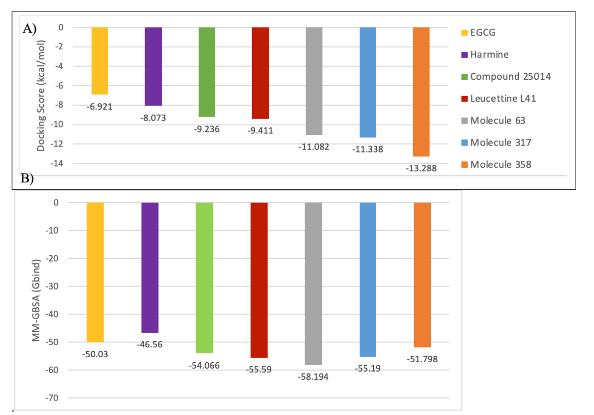
Figure 2. Comparative binding analysis of the lead and optimized compounds. (A) Graphical representation of XP Docking scores. (B) Calculated MM-GBSA binding free energies (ΔG_{bind}) relative to reference standards.

Safety and Metabolic Stability: In the ADMETlab 3.0 analysis, Molecule-358 displayed a superior safety profile. It showed low probabilities for hERG (human ether-a-go-go related gene) inhibition (0.065) and Drug-Induced Liver Injury (DILI) (0.249) as computed in Table 7, addressing key attrition risks in early discovery. Furthermore, the compound exhibited negligible inhibition across major CYP isoforms (CYP1A2, CYP2C9, CYP2D6, CYP3A4 scores < 0.13 probability), suggesting a low risk of causing drug-drug interactions (DDIs).

BBB Permeability: A critical design goal was CNS penetration. Molecule-358 achieved a favorable BBB permeability probability score (0.49).

In conclusion, Molecule-358 and Molecule-63 represented a potent and metabolically stable candidate exhibiting the optimal balance of potency and safety, warranting further in vitro and in vivo validation.

Table 7. Comparative Analysis of Lead and Optimized Compounds (Docking, MM-GBSA, ADMET)

Compound ID | Docking score (kcal/mol) | MM-GBSA (ΔG_{bind}) | BBB permeability | hERG | DILI | H-HT | CYP1A2 inhibitor | CYP2C9 inhibitor | CYP2D6 inhibitor | CYP3A4 inhibitor
25014 | -9.236 | -54.07 | 0.274 | 0.213 | 0.503 | 0.56 | 0.826 | 0.082 | 0.604 | 0.328
Molecule 63 | -11.082 | -58.19 | 0.003 | 0.069 | 0.202 | 0.476 | 0.011 | 0.006 | 0.128 | 0
Molecule 317 | -11.338 | -55.19 | 0.067 | 0.063 | 0.134 | 0.475 | 0.998 | 0.165 | 0.932 | 0.021
Molecule 358 | -13.288 | -51.8 | 0.487 | 0.065 | 0.249 | 0.458 | 0.106 | 0.003 | 0.011 | 0.003
Leucettine | -9.411 | -55.59 | 0.949 | 0.55 | 0.97 | 0.69 | 0.998 | 0.3 | 0.004 | 0.978
Harmine | -8.073 | -46.56 | 0.235 | 0.40 | 0.92 | 0.68 | 1 | 0.001 | 0.997 | 0.825
EGCG | -6.921 | -50.03 | 0.003 | 0.05 | 0.94 | 0.24 | 0 | 0.206 | 0 | 0.085

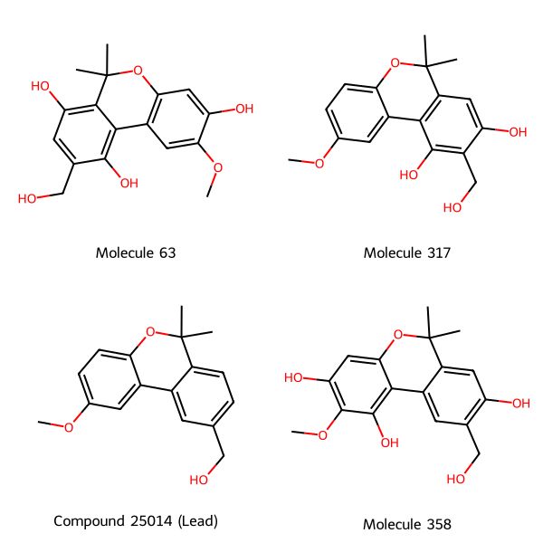
Figure 3. 2D chemical structures of the lead Compound 25014 and its optimized analogs (Molecule 63, 317, and 358).

A B
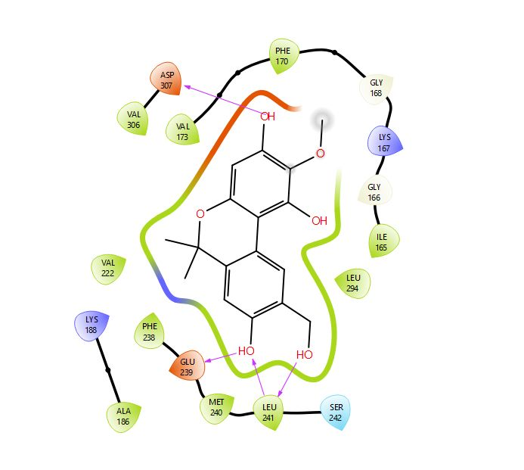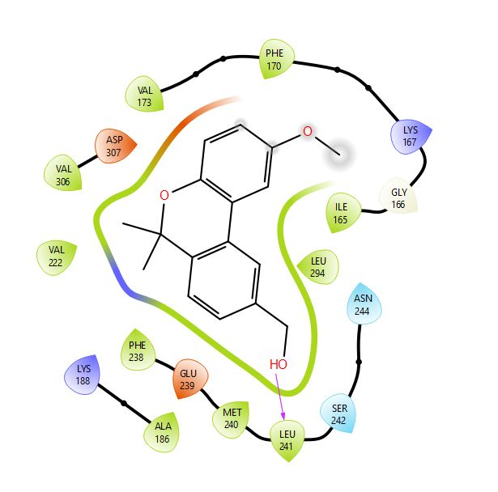

Figure 4. 2D interaction of the optimized analog, molecule-358 (A) and the compound 25014 (B) against the target protein (3ANR).

3.5. Density Functional Theory (DFT) Analysis
Thermodynamic Analysis
The thermodynamics properties of molecular compounds are essential parameters to characterize the binding properties of the molecules and degree of potency of bonding interactions with their target receptors. The parameters examined in this study include the electronic energy, enthalpy and Gibb’s free energy. These parameters serve as insights to areas of optimization, especially structurally to enhance the binding force of interaction at the target protein. The binding free energy depicts the possibility and extent of interactions. Gibb’s free energy is a vital thermodynamic index used to describe the ligand-receptor interaction. It shows the possibility of biomolecular events occurring. A negative Gibb’s free energy indicates that binding can occur spontaneously without the requirement of an external energy while a positive energy indicates the requirement of an external energy (Balogun et al., 2021). The characterization was carried out for the lead compounds 28296, 25014, molecules 63, 317, 358, EGCG, Harmine and Leucettine. The values of the electronic energy, enthalpy, Gibb’s free energy and dipole moment were computed in the Table 8.
The optimized compound, molecule-358 (-0.25 Hartree) shows the best thermodynamic profile compared to the other lead compounds and compared compounds (Leucettine, Harmine, EGCG) with the highest free energy, indicating the compound has the highest source of internal energy needed to form binding interactions without the requirement of external influence. Molecule-63 (7.32) and molecule-358 (4.78) had the highest value for dipole moment signifying they were the most biologically active amongst all the compounds in the study, having the highest chance for bond interactions with the receptor protein.

Table 8. Molecular weight, electronic energy, enthalpy, Gibb’s free energy and dipole moment values obtained via DFT at the B3LYP/6-31G* level.

Compound ID | Molecular Weight (AMU) | Electronic Energy (AU) | Enthalpy (AU) | Gibbs’s Free Energy (HARTREE) | Dipole Moment (D)
Compound 25014 | 270.328 | -884.311 | -884.325 | -0.0138 | 1.86
Compound 28296 | 304.301 | -1032.150 | -1032.170 | -0.0199 | 3.46
Molecule 63 | 318.325 | -1109.957 | -1109.982 | -0.0258 | 7.32
Molecule 317 | 302.326 | -1034.748 | -1034.775 | -0.0272 | 2.17
Molecule 358 | 318.325 | -1110 | -1110 | -0.25 | 4.78
Leucettine | 307.309 | -1045.559 | -1045.571 | -0.0209 | 2.35
Harmine | 212.252 | -687.350 | -687.364 | -0.0015 | 3.49
EGCG | 458.375 | -1676.610 | -1676.657 | -0.0466 | 4.09

Frontier Molecular Orbital (FMOs)
The electronic structure of molecules helps predict their orbital reactivity and stability during and after bond formations. Key electron properties of the molecules, the FMOs, include the HOMO (highest occupied molecular orbital) and LUMO (lowest molecular orbital) especially in quantum chemistry mechanical analysis. The molecular parameters are a measure of the electron distribution which characterize the bond formations (Balogun et al., 2021). The E_{HOMO} best describes the electron-donating capability, a higher value of E_{HOMO} suggests that the molecule is more likely to act as an electron donor (AL-Makhzumi et al., 2018). The E_{LUMO} is a measure of a molecule’s ability to accept electron, a lower E_{LUMO} value of a molecule shows an increased possibility to accept electrons. Therefore, a higher value for E_{HOMO} and a lower value for E_{LUMO} signifies lower stability and increased reactivity of a molecule (Balogun et al., 2021).
From Table 9, the E_{HOMO} values from the studied compounds, molecule 63 (-4.74 eV) had the highest value for E_{HOMO,} then molecule 358 (-4.95 eV), which shows better tendency to donate electrons than other compounds. Also, the calculated E_{LUMO} value, as shown in Table 2, shows that compound 28296 (-2.58 eV) had the lowest value, having the highest potential of accepting electron.

Global Reactivity Descriptors (GRDs)
The HUMO and LUMO energies were used to estimate the chemical descriptors. The value of the difference between E_{HOMO} and E_{LUMO} denotes the E_{g}, energy band gap which is indicative of the stability and reactivity capabilities. The most reactive and least stable is the compound 28296 with the energy band gap value determined to be 2.97 eV, as seen in Table 9.
The molecule-63 has the least ionization energy (I) corresponding to 4.74 eV, signifying it is the most reactive with less energy to release electrons. Compound 28296 (2.58 eV) was determined to have the highest the electron affinity (A), suggestive of high reactivity.
Understanding chemical hardness and softness are vital to predicting the reactivity of a chemical system (Mortier et al., 1985). From Table 9, Harmine (2.36 eV) and the molecule-358 (2.32 eV) were the hardest compounds having the highest-ranking Eg value. Compound 28296 (0.67 eV-1) was the softest compared to other compounds.
Electrophilicity is indicative in predicting compound stability. The least electrophilic was determined to be the compound, molecule-358 with chemical potential of -2.63 eV. This indicates the possibility of gaining electronic charge while resisting electron transfer, ensuring ideal stability and, not being subjective to decomposition. Electronegativity (χ), is a descriptor that profiles the ability of compounds to draw electrons. Table 9 suggests the most electronegative compound was the compound 28296 (4.07 eV).
The compound, molecule-358 has the least (I) value, though having the second highest EHOMO, which may indicate lesser reactivity and higher stability. Taking into factor the other descriptors it is suggestive that the optimized compound, molecule-358 was the most reactively stable compound studied and has the highest possibility of suitable interaction with the target protein 3ANR.
Table 9. Chemical parameters obtained via DFT at the B3LYP/6-31G* level.
Abbreviations: (E_{HOMO}), highest occupied molecular orbital energy; (E_{LUMO}), lowest unoccupied molecular orbital energy; (E_{g}), energy band gaps; (I), ionization energy; (A), electron affinity; (η), chemical hardness; (δ) chemical softness; (µ), chemical potential; (χ), electronegativ
Compound ID | E_{HOMO} (eV) | E_{LUMO} (eV) | E_{g} (eV) | I (eV) | A (eV) | η (eV) | δ  (eV⁻¹) | µ  (eV) | χ (eV)
Compound 25014 | -5.29 | -0.93 | 4.36 | 5.29 | 0.93 | 2.18 | 0.46 | -3.11 | 3.11
Compound 28296 | -5.55 | -2.58 | 2.97 | 5.55 | 2.58 | 1.49 | 0.67 | -4.07 | 4.07
Molecule 63 | -4.74 | -0.57 | 4.17 | 4.74 | 0.57 | 2.09 | 0.48 | -2.66 | 2.66
Molecule 317 | -5.12 | -0.67 | 4.45 | 5.12 | 0.67 | 2.23 | 0.45 | -2.90 | 2.90
Molecule 358 | -4.95 | -0.31 | 4.64 | 4.95 | 0.31 | 2.32 | 0.43 | -2.63 | 2.63
Leucettine | -5.03 | -1.74 | 3.29 | 5.03 | 1.74 | 1.65 | 0.61 | -3.39 | 3.39
Harmine | -5.53 | -0.82 | 4.71 | 5.53 | 0.82 | 2.36 | 0.42 | -3.18 | 3.18
EGCG | -5.56 | -1.01 | 4.55 | 5.56 | 1.01 | 2.28 | 0.44 | -3.29 | 3.29

Compound ID | HOMO | LUMO
Compound 25014 | 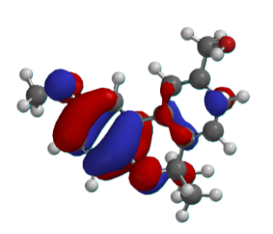 | 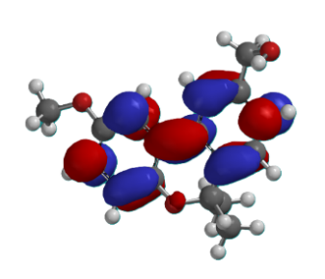
Compound 28296 | 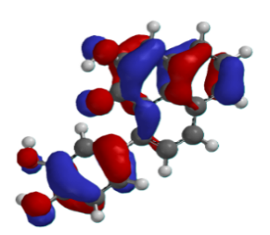 | 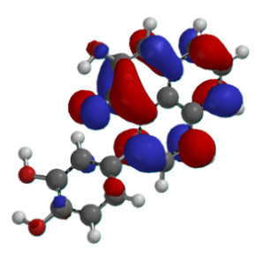
Harmine | 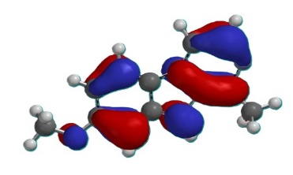 | 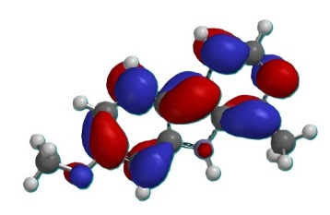
Leucettine | 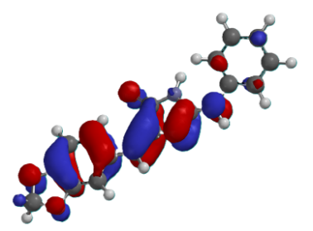 | 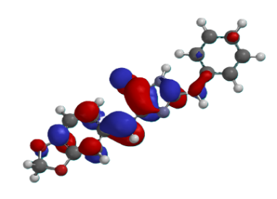
Epigallocatechin Gallate | 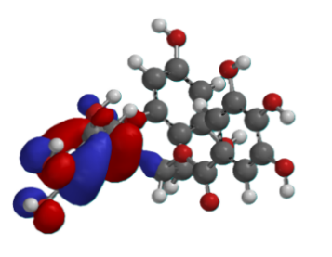 | 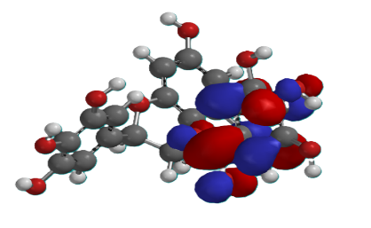
Table 10. The HOMO and LUMO of the lead compounds and compared compounds.

Table 11. The HOMO, LUMO and optimized structure of the analogs.

Compound ID | Optimized Structure | HOMO | LUMO
Molecule 317 | 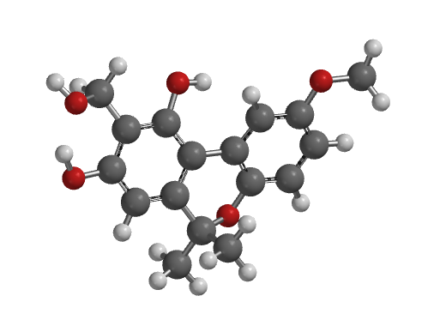 | 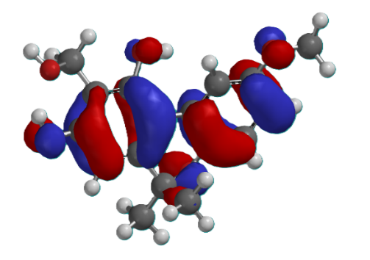 | 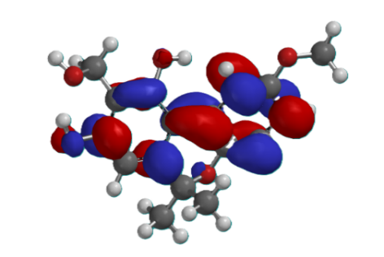
Molecule 358 | 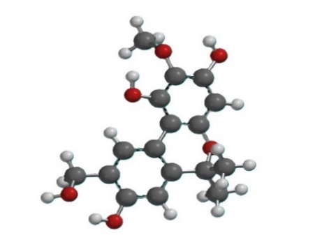 | 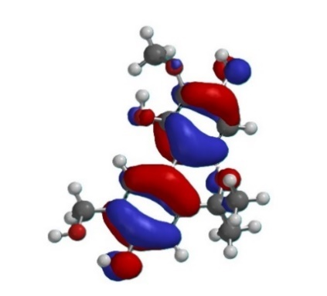 | 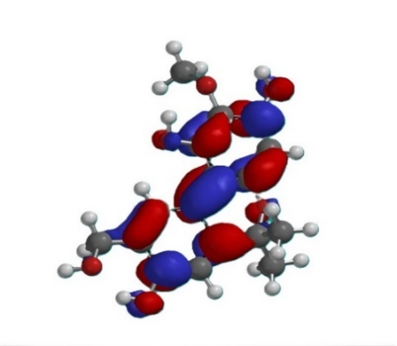
Molecule 63 | 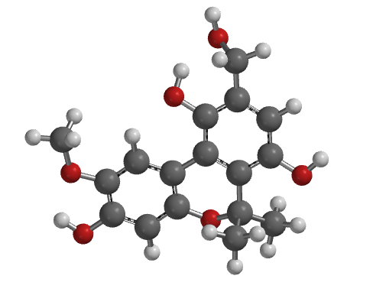 | 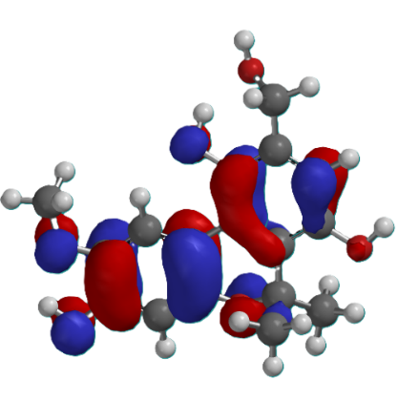 | 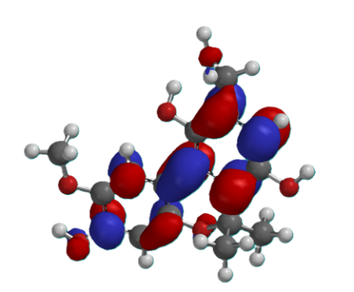

- Conclusion
This study shows the potential of novel DYRK1A inhibitors for CNS drug discovery in the absence of established standard therapies. In-silico modeling of retrieved and optimized compounds against the 3ANR target protein identified two lead compounds and three analogs as promising candidates for targeted DYRK1A gene suppression. While compounds 28296 and 25014 showed strong ligand–protein binding and stability, their toxicity profiles were suboptimal. Optimized analogs Molecule-63, Molecule-317, and Molecule-358 exhibited improved toxicity profiles, high predicted BBB permeability, and maintained superior docking scores compared with reference compounds Leucettine, EGCG, and Harmine. DFT analyses further confirmed a favorable balance between stability and reactivity for these analogs. These findings provide a solid foundation for subsequent in-vitro and in-vivo validation, advancing the development of targeted DYRK1A inhibitors in Down’s syndrome associated cognitive impairment.

References
- Alam, P., Arshad, M.F., & Sharma, P. (2025). Structural Dynamics and Network Pharmacology for the Discovery of Inhibitors Targeting DYRK1 A in Neurological Disorders. Mol Neurobiol, 62(9):11064-11088. doi: 10.1007/s12035-025-04935-0. Epub 2025 Apr 22. PMID: 40261606.
- AL-Makhzumi, Q., Abdullah, H.I., & AL-Ani, R.R. (2018). Theoretical study of N-methyl-3-phenyl-3-(-4 (Trifluoromethyl)phenoxy)propan as a drug and its five derivatives. J Biosci Med. 6:80-98.
- Antonarakis, S.E., Skotko, B.G., Rafii, M.S., Strydom, A., Pape, S.E., Bianchi, D.W., Sherman, S.L., & Reeves, R.H. (2020). Down syndrome. Nat Rev Dis Primers, 6(1):9. doi: 10.1038/s41572-019-0143-7. PMID: 32029743; PMCID: PMC8428796.
- Balogun, Toheeb A et al. (2021) Computational Evaluation of Bioactive Compounds from Colocasia affinis Schott as a Novel EGFR Inhibitor for Cancer Treatment. Cancer informatics vol, 20 11769351211049244. doi:10.1177/11769351211049244.
- Bitew, M., Desalegn, T., Demissie, T.B., Belayneh, A., Endale, M., & Eswaramoorthy, R. (2021). Pharmacokinetics and drug-likeness of antidiabetic flavonoids: Molecular docking and DFT study. PLoS One, 16(12):e0260853. doi: 10.1371/journal.pone.0260853. PMID: 34890431; PMCID: PMC8664201.
- Bodun, D.S., Omoboyowa, D.A., Omotuyi, O.I., Olugbogi, E.A., Balogun, T.A., Ezeh, C.J., & Omirin, E.S. (2023). QSAR-based virtual screening of traditional Chinese medicine for the identification of mitotic kinesin Eg5 inhibitors. Comput Biol Chem, 104:107865. doi: 10.1016/j.compbiolchem.2023.107865. Epub 2023 Apr 4. PMID: 37062146.
- Choudhury, A., Khan, S., Saeed, M.U., Mohammad, T., Hussain, A., AlAjmi, M.F., Fatima, U., Islam, A., & Hassan, M.I. (2025). Structure-guided discovery of tau-phosphorylating kinase DYRK1A inhibitors for therapeutic targeting of neuroinflammatory diseases: Insights from microsecond MD simulation and MMPBSA analyses. Biochem Biophys Res Commun, 15;775:152166. doi: 10.1016/j.bbrc.2025.152166. Epub 2025 Jun 8. PMID: 40505550.
- de Souza, M.M., Cenci, A.R., Teixeira, K.F., Machado, V., Mendes Schuler, M.C.G., Gonçalves, A.E., Paula, D.A, André, C.C., Gomes, F.L.L., de Oliveira, A.S., & Andricopulo, A.D. (2023). DYRK1A Inhibitors and Perspectives for the Treatment of Alzheimer's Disease. Curr Med Chem, 30(6):669-688. doi: 10.2174/0929867329666220620162018. PMID: 35726411.
- Debdab, M., Carreaux, F., Renault, S., Soundararajan, M., Fedorov, O., Filippakopoulos, P., Lozach, O., Babault, L., Tahtouh, T., Baratte, B., Ogawa, Y., Hagiwara, M., Eisenreich, A., Rauch, U., Knapp, S., Meijer, L., & Bazureau, J. P. (2011). Leucettines, a class of potent inhibitors of cdc2-like kinases and dual specificity, tyrosine phosphorylation regulated kinases derived from the marine sponge leucettamine B: modulation of alternative pre-RNA splicing. Journal of medicinal chemistry, 54(12), 4172–4186. https://doi.org/10.1021/jm200274d.
- Deboever, E., Fistrovich, A., Hulme, C., & Dunckley, T. (2022). The Omnipresence of DYRK1A in Human Diseases. International Journal of Molecular Sciences, 23(16). https://doi.org/10.3390/ijms23169355
- Duchon, A., & Herault, Y. (2016). DYRK1A, a Dosage-Sensitive Gene Involved in Neurodevelopmental Disorders, Is a Target for Drug Development in Down Syndrome. Front Behav Neurosci, 10:104. doi: 10.3389/fnbeh.2016.00104. PMID: 27375444; PMCID: PMC4891327.
- Friesner, R. A., Banks, J. L., Murphy, R. B., Halgren, T. A., Klicic, J. J., Mainz, D. T., & Shenkin, P. S. (2004). Glide: a new approach for rapid, accurate docking and scoring. 1. Method and assessment of docking accuracy. Journal of Medicinal Chemistry, 47(7), 1739–1749. doi:10.1021/jm0306430.
- Friesner, R. A., Banks, J. L., Murphy, R. B., Halgren, T. A., Klicic, J. J., Mainz, D. T., ... & Irwin, J. J. (2004). Glide: a new approach for rapid, accurate docking and scoring. 1. Method and assessment of docking accuracy. Journal of Medicinal Chemistry, 47(7), 1739-1749.
- Fu, L., Shi, S., Yi, J., Wang, N., He, Y., Wu, Z., Peng, J., Deng, Y., Wang, W., Wu, C., Lyu, A., Zeng, X., Zhao, W., Hou, T., & Cao, D. (2024), ADMETlab 3.0: an updated comprehensive online ADMET prediction platform enhanced with broader coverage, improved performance, API functionality and decision support. Nucleic Acids Res, 5;52(W1):W422-W431. doi: 10.1093/nar/gkae236. PMID: 38572755; PMCID: PMC11223840.
- Genheden, S., & Ryde, U. (2015). The MM/PBSA and MM/GBSA methods to estimate ligand-binding affinities. Expert Opinion on Drug Discovery, 10(5), 449–461. doi:10.1517/17460441.2015.1032936.
- Gleeson, M.P. (2008). Generation of a set of simple, interpretable ADMET rules of thumb. J Med Chem, 51(4):817-34. Doi: 10.1021/jm701122q. Epub 2008 Jan 31. PMID: 18232648.
- Godfrey, M., & Lee, N.R. (2018). Memory profiles in Down syndrome across development: a review of memory abilities through the lifespan. J Neurodev Disord, 10(1):5. doi: 10.1186/s11689-017-9220-y. PMID: 29378508; PMCID: PMC5789527.
- Khalid, H., Ahmad, I., Butt, M.H., Shamim, A., Nishan, U., Ali, A., Dib, H., Zaman, A., & Shah, M. (2025). Computational Profiling of Asteraceae-Derived Phytochemicals Targeting S-Adenosylhomocysteine Hydrolase (SAHH) of Naegleria fowleri. ChemistrySelect, 10, e00905. https://doi.org/10.1002/slct.202500905.
- Kim, M.T., Sedykh, A., Chakravarti, S.K., Saiakhov, R.D., & Zhu, H. (2014). Critical evaluation of human oral bioavailability for pharmaceutical drugs by using various cheminformatics approaches. Pharm Res, 31(4):1002-14. Doi: 10.1007/s11095-013-1222-1. Epub 2013 Dec 3. PMID: 24306326; PMCID: PMC3955412.
- Kitchen, D. B., Decornez, H., Furr, J. R., & Bajorath, J. (2004). Docking and scoring in virtual screening for drug discovery: methods and applications. Nature Reviews Drug Discovery, 3(11), 935–949.
- Lipinski, C. A., Lombardo, F., Dominy, B. W., & Feeney, P. J. (2001). Experimental and computational approaches to estimate solubility and permeability in drug discovery and development settings. Advanced Drug Delivery Reviews, 46(1–3), 3–26. doi:10.1016/s0169-409x(00)00129-0.
- Lipinski, C.A. (2004) Lead- and drug-like compounds: the rule-of-five revolution. Drug Discov. Today Technol. 1:337-341, https://doi.org/10.1016/j.ddtec.2004.11.007.
- Liu, T., Wang, Y., Wang, J., Ren, C., Chen, H., & Zhang, J. (2022). DYRK1A inhibitors for disease therapy: Current status and perspectives. European journal of medicinal chemistry, 229, 114062. https://doi.org/10.1016/j.ejmech.2021.114062.
- Lott, I.T., & Head, E. (2019). Dementia in Down syndrome: unique insights for Alzheimer disease research. Nat Rev Neurol, 15(3):135-147. doi: 10.1038/s41582-018-0132-6. PMID: 30733618; PMCID: PMC8061428.
- Meanwell, N. A. (2018). Fluorine and fluorinated motifs in the design and application of bioisosteres for drug design. Journal of Medicinal Chemistry, 61(13), 5822–5880. doi:10.1021/acs.jmedchem.7b01788.
- Mortier, W.J., Van Genechten, K., & Gasteiger, J (1985). Electronegativity equalization: application and parametrization. J Am Chem Soc. 107:829-835
- Omoboyowa, D.A., Balogun, T.A., Saibu, O.A., Chukwudozie, O.S., Alausa, A., Olubode, S.O., Aborode, A.T., Batiha, G.E., Bodun, D.S., Musa, S.O. (2022). Structure-based discovery of selective CYP17A1 inhibitors for Castration-resistant prostate cancer treatment. Biol. Methods. Protocols. https://doi.org/10.1093/ biomethods/bpab026.
- Osunnaya, S,A., Wilberforce, K.N., Ifeoluwa, A., Ibilola, A.O., Precious, O.A., Ayodele, O.E., Adeola, S.A., Sheriffdeen, A.A., Olatunde, S.O., Njogu, M.K., Taiwo, H.O., Adedoyin. J.O., & Damilola, S,B, (2025). Identification and exploration of novel FGFR-1 inhibitors in the Lotus database for Cholangiocarcinoma (CCA) treatment, Aspects of Molecular Medicine, Volume 5, 2025, 100085, ISSN 2949-6888, https://doi.org/10.1016/j.amolm.2025.100085.
- Owolade, A.J., Bodun, D., Akinbi, E.O., Oni, S.A., Omojuyigbe, J.O., Olatunji, T.W., Sylvanus, A.C., & Oke, A.E. (2025). Computational design of novel diphtheria toxin inhibitors using natural products-based drug discovery, The Microbe, 7:100359, ISSN 2950-1946, https://doi.org/10.1016/j.microb.2025.100359.
- Pajouhesh, H., & Lenz, G.R. (2005) Medicinal chemical properties of successful central nervous system drugs. NeuroRx, 2(4):541-53. Doi: 10.1602/neurorx.2.4.541. PMID: 16489364; PMCID: PMC1201314.
- Pardridge, W. M. (2012). Drug transport across the blood–brain barrier. Journal of Cerebral Blood Flow & Metabolism, 32(11), 1959–1972. doi:10.1038/jcbfm.2012.126.
- Qiu, N., Qian, C., Guo, T., Wang, Y., Jin, H., Yao, M., Li, M., Guo, T., Lv, Y., Si, X., Wu, S., Wang, H., Zhang, X., & Xia, J. (2024). Discovery of a novel chemotype as DYRK1A inhibitors against Alzheimer's disease: Computational modeling and biological evaluation. Int J Biol Macromol, 269(Pt 1):132024. doi: 10.1016/j.ijbiomac.2024.132024. Epub 2024 May 3. PMID: 38704072.
- Rowbottom, M.W., Faraoni, R., Chao, Q., Campbell, B.T., Lai, A.G., Setti, E., Ezawa, M., Sprankle, K.G., Abraham, S., Tran, L., Struss, B., Gibney, M., Armstrong, R.C., Gunawardane, R.N., Nepomuceno, R.R., Valenta, I., Hua, H., Gardner, M.F., Cramer, M.D., Gitnick, D., Insko, D.E., Apuy, J.L., Jones-Bolin, S., Ghose, A.K., Herbertz, T., Ator, M.A., Dorsey, B.D., Ruggeri, B., Williams, M., Bhagwat, S., James, J., & Holladay, M.W. (2012). Identification of 1-(3-(6,7-dimethoxyquinazolin-4-yloxy)phenyl)-3-(5-(1,1,1-trifluoro-2-methylpropan-2-yl)isoxazol-3-yl)urea hydrochloride (CEP-32496), a highly potent and orally efficacious inhibitor of V-RAF murine sarcoma viral oncogene homologue B1 (BRAF) V600E. J Med Chem, 55(3):1082-105. doi: 10.1021/jm2009925. Epub 2012 Jan 23. PMID: 22168626.
- Rutz, A., Sorokina, M., Galgonek, J., Mietchen, D., Willighagen, E., Gaudry, A., Graham, J. G., Stephan, R., Page, R., Vondrášek, J., Steinbeck, C., Pauli, G. F., Wolfender, J. L., Bisson, J., & Allard, P. M. (2022). The LOTUS initiative for open knowledge management in natural products research. eLife, 11, e70780. https://doi.org/10.7554/eLife.70780.
- Samia, E.O., Tawasol, M.I., Omer, A.K., Amna, M.A., Alaa, A.M., Walaa, I., & Abdulrahim, A.A. (2022). Drug repurposing for SARS-CoV-2 main protease: Molecular docking and molecular dynamics investigations. Biochemistry and Biophysics Reports, (29)01225, ISSN 2405-5808, https://doi.org/10.1016/j.bbrep.2022.101225.
- Scarano, N. (2025). Druggable targets to contrast Alzheimer’s disease: molecular modelling approaches for the drug design process. PhD Thesis, University of Genoa.
- Serrano-Candelas, E., Carpio, L.E., Gozalbes, R. (2023). Computational Modeling of DYRK1A Inhibitors as Potential Anti-Alzheimer Agents. In: Roy, K. (eds) Computational Modeling of Drugs Against Alzheimer’s Disease. Neuromethods, vol 203. Humana, New York, NY. https://doi.org/10.1007/978-1-0716-3311-3_10.
- Stagni, F., Giacomini, A., Emili, M., Guidi, S., Ciani, E., & Bartesaghi, R. (2017). Epigallocatechin gallate: A useful therapy for cognitive disability in Down syndrome?. Neurogenesis (Austin, Tex.), 4(1), e1270383. https://doi.org/10.1080/23262133.2016.1270383.
- Trott, O., & Olson, A. J. (2010). AutoDock Vina: improving the speed and accuracy of docking with a new scoring function, efficient optimization, and multithreading. Journal of Computational Chemistry, 31(2), 455-461.
- Wang, J., Dai, W., & Jia, L. (2019). Molecular docking and molecular dynamics simulation study of novel inhibitors targeting DYRK1A kinase. Scientific Reports, 9, 1-13.
- Wang, W., Donini, O., Reyes, C.M., et al. (2001). Biomolecular simulations: recent developments in force fields, simulations of enzyme catalysis, protein-ligand, protein-protein, and protein-nucleic acid non-covalent interactions. Annu Rev Biophys Biomol Struct, 30:211–43. https://doi.org/10.1146/annurev. biophys.30.1.21.
- Xiong, G., Wu, Z., Yi, J., Fu, L., Yang, Z., Hsieh, C., ... & Cao, D. (2021). ADMETlab 2.0: an integrated online platform for accurate and comprehensive ADMET profiling. Nucleic Acids Research, 49(W1), W5–W14. doi:10.1093/nar/gkab255.

